|  |
| --- |
| **Object Oriented Paradigm- Sequence Diagram/Class Diagram** |

|  |
| --- |
| **19CSE204** |

**DEGREE & BRANCH : BTech(CSE)**

**Duration : 2 hours 5/Oct/2020**

|  |  |  |  |  |
| --- | --- | --- | --- | --- |
| **Q.**  **No.** | **Question** | **BTL/**  **Diffficulty level(Easy/Medium/Difficult)** | **CO** | **Diagram to be drawn** |
| 1 | A university provides classes to students registered at the university. University courses are taught in classes. A university course has a name, teaching department, and prerequisite courses. A class is taught by at least one instructor in a fixed room at a set of scheduled times. An instructor can be a regular faculty member of a sessional appointment. A faculty member belongs to a department where their office is located. All faculty members are contactable by email. Each student has a name, student number, address, email address, and an indication that they are registered. Classes are offered in the fall, winter, and spring semesters. | Apply, DL -2 | **CO02** | **Sequence Diagram**  **And**  **Class Diagram** |
| 2. | In a Hospital, whenever new patients are seen for the first time, they complete a patient information form that asks their name, address, phone number and insurance carrier, which are stored in the patient information file. Patients can be signed up with only one carrier, but they must be signed up to be seen by the doctor. Each time a patient visits the doctor, an insurance claim is sent to the carrier for payment. The claim must contain information about the visit, such as the date, purpose, and cost. It would be possible for a patient to submit two claims on the same day. | Apply, DL -2 | **CO02** | **Class Diagram** |

**Rubrics for Evaluation**

|  |  |  |  |
| --- | --- | --- | --- |
|  | **Good** | **Average** | **Need Improvement** |
| **Design(15)** | **12-15** | **8-11** | **0-6** |
| **Visualisation(15)** | **12-15** | **8-11** | **0-6** |

1)

CLASS DIAGRAM:

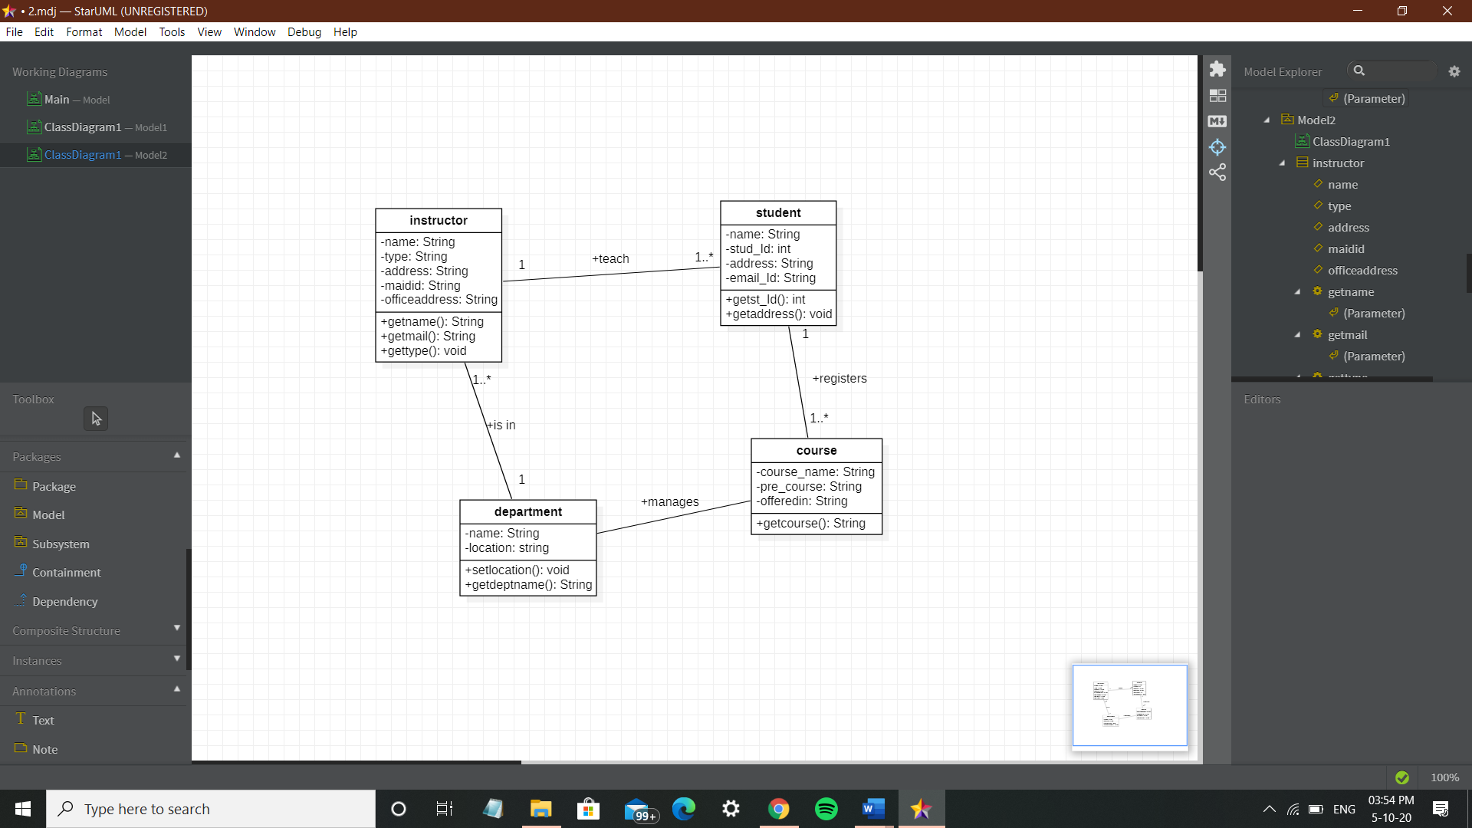

2)

SEQUENCE DIAGRAM:

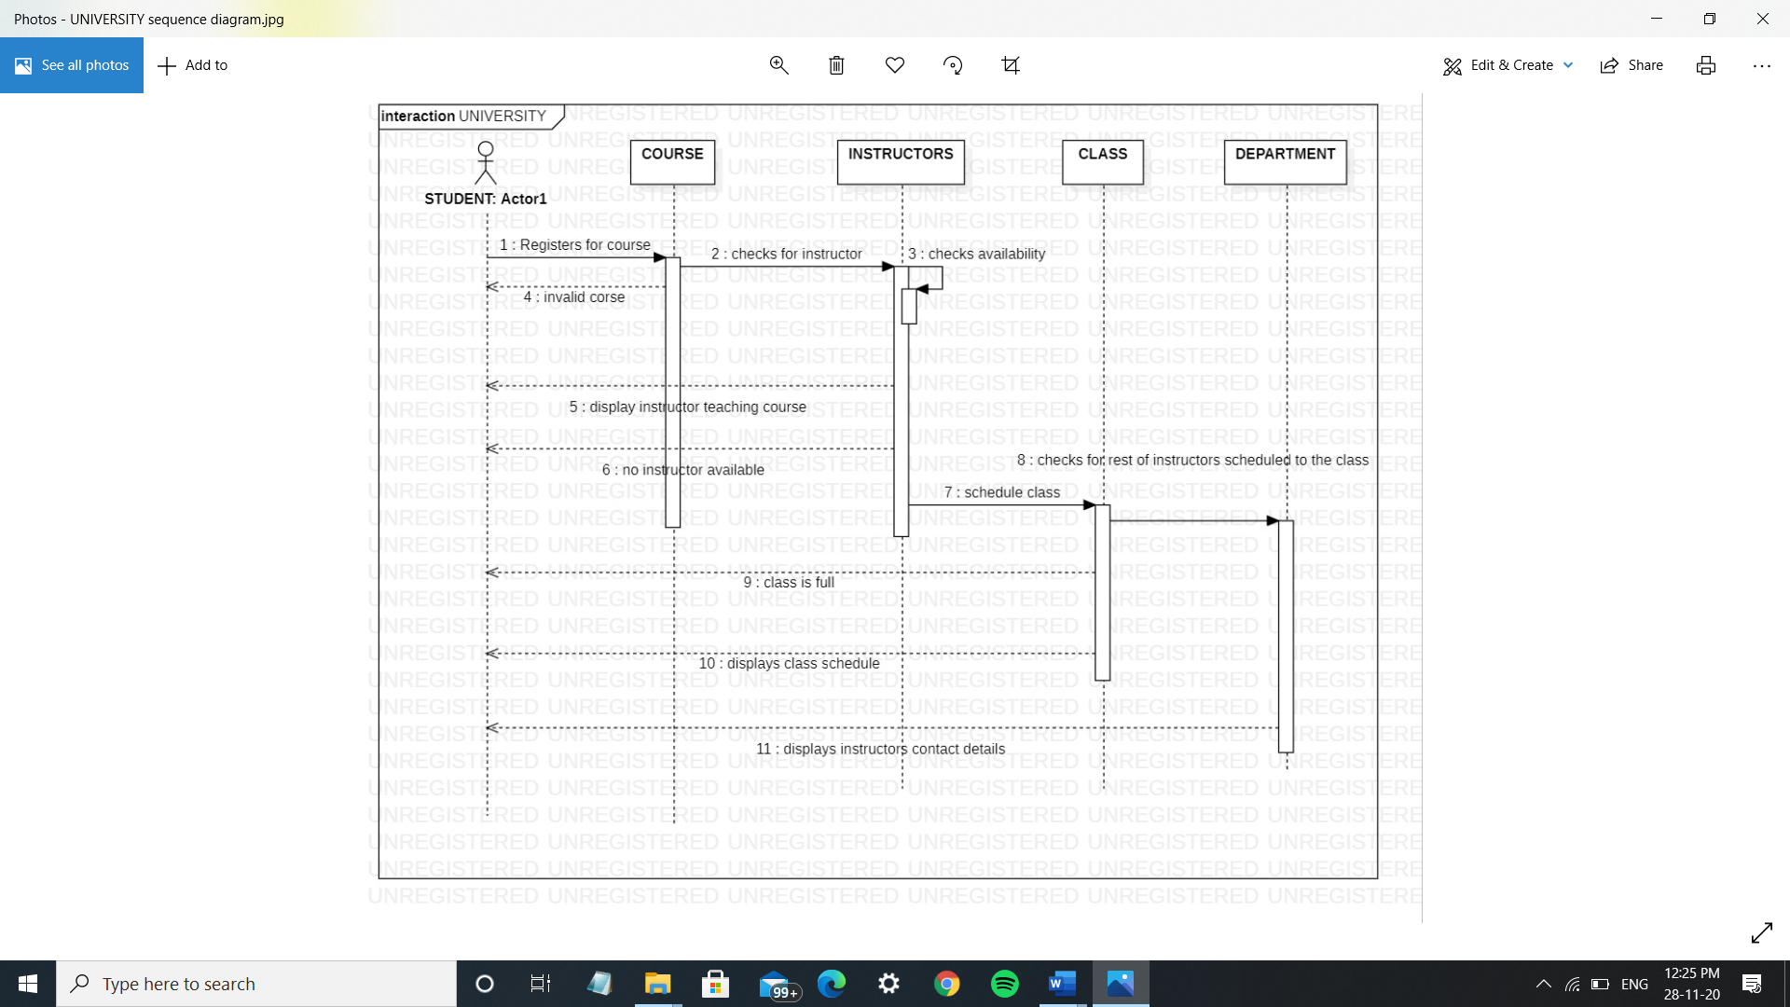

2)

CLASS DIAGRAM:

